Below are a couple of images taken from the output of the VNA that demonstrate the frequency response of the 3rd generation filter that we are designing for practicum this fall. In the first image, the response of the filter is shown with the pass band indicated by markers 1 and 2. Marker 3 is the intended signal of the filter, 436.5 MHz. Here, the desired frequency is slightly outside of the pass band.

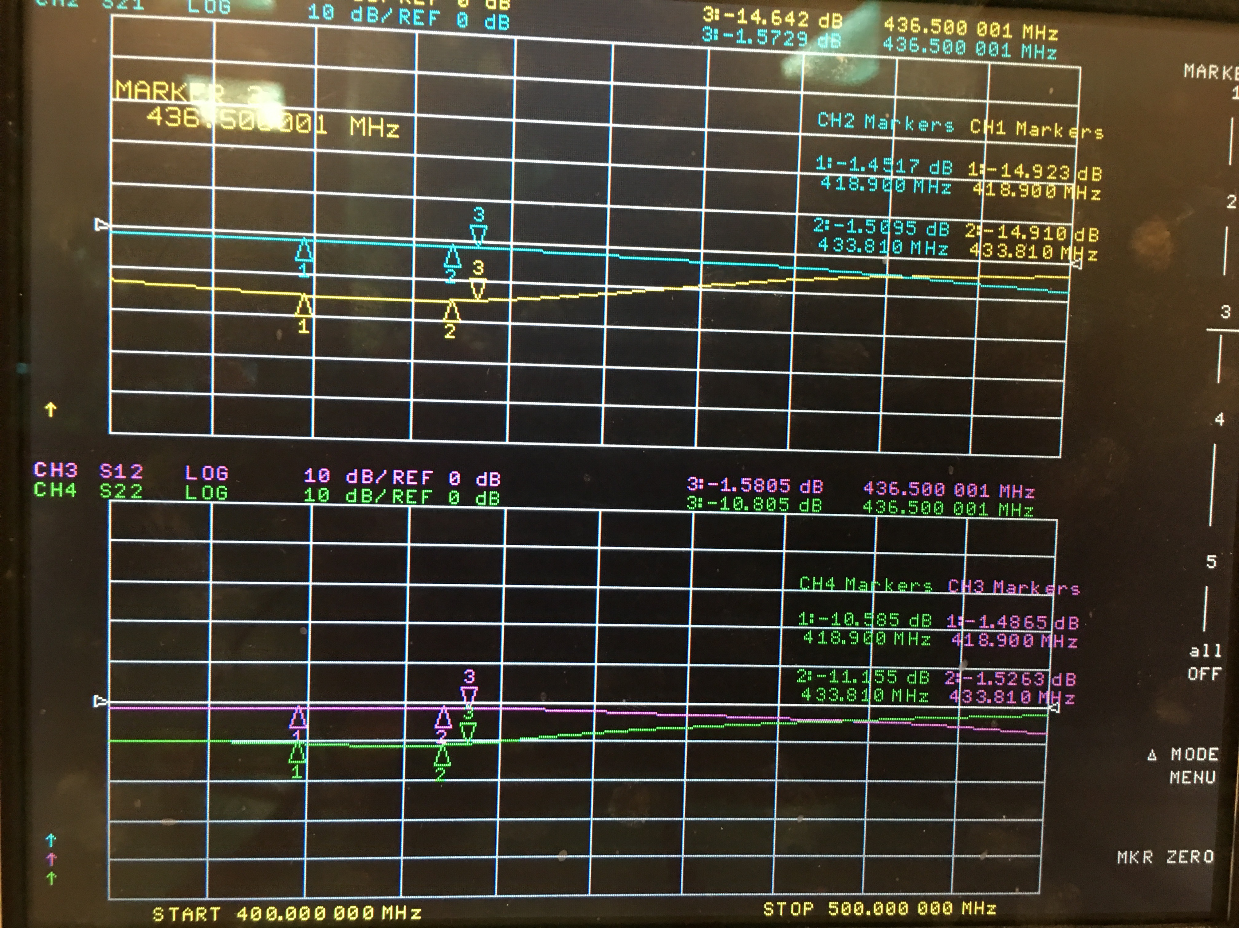

Figure 1. 3rd Rev pass band response without modification

In the image below, marker 3 shows the intended location of the 2nd harmonic of the desired 436.5 MHz signal. Here, the measured frequency is 647.41 MHz, which is well below the expected frequency of 873 MHz. Ideally, the 2nd harmonic will fall into the “dip” seen in the stop band in figure 2.

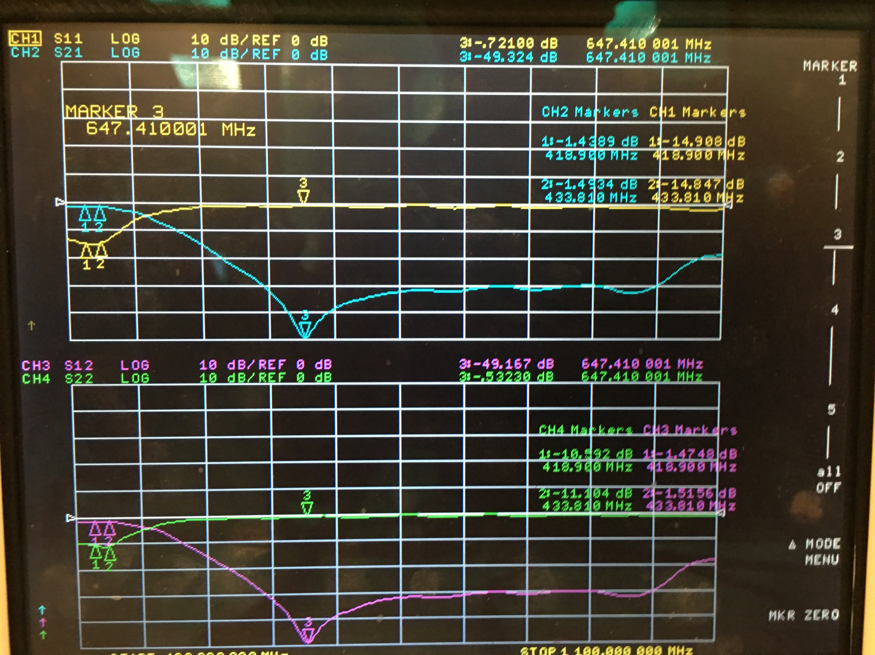

Figure 2. 3rd Rev 2nd harmonic response without modification

Improving the response of the filter requires a few modifications that have not been made in any previous builds. First, copper tape is applied to both the top and bottom edges of the board in order to secure the ground plane around the filter. To further this process, the SMA connectors are soldered to the large ground plane on the bottom layer of the board. In Figure 3 below, it is shown that after the modification was performed the center frequency in the “dip” of the filter has increased by about 50 MHz from where it was before the procedure made. Also, the attenuation has increased from -49dB to -57dB at this frequency.

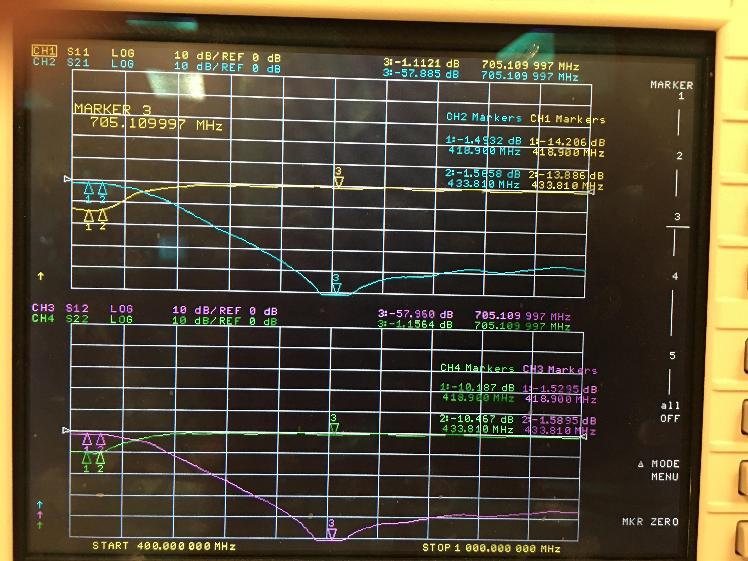

Figure 3. 3rd Rev 2nd harmonic response with first modification

Figure 4, below, shows that the 2nd harmonic of our signal is only -37dB down. We expect 40dB attenuation.

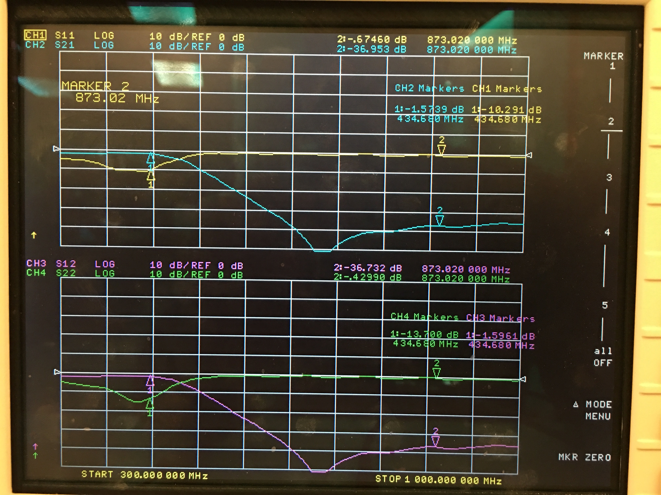

Figure 4. 3rd Rev 2nd harmonic response with first modification

The final modification to the filter includes drilling vias through the board to connect the bottom and top ground planes even further. This technique is very common in RF design. Most of the vias were placed next to the grounded side of components. Wire was used through the vias to connect the top and bottom layers by soldering the wire to either side.

The pass band of the filter is shown below. Here our signal is inside the bass band, but it is not centered in the pass band. A detail of the pass band response is shown in Figure 6, below. More work is needed to improve the response, but these modifications are improving the filter.

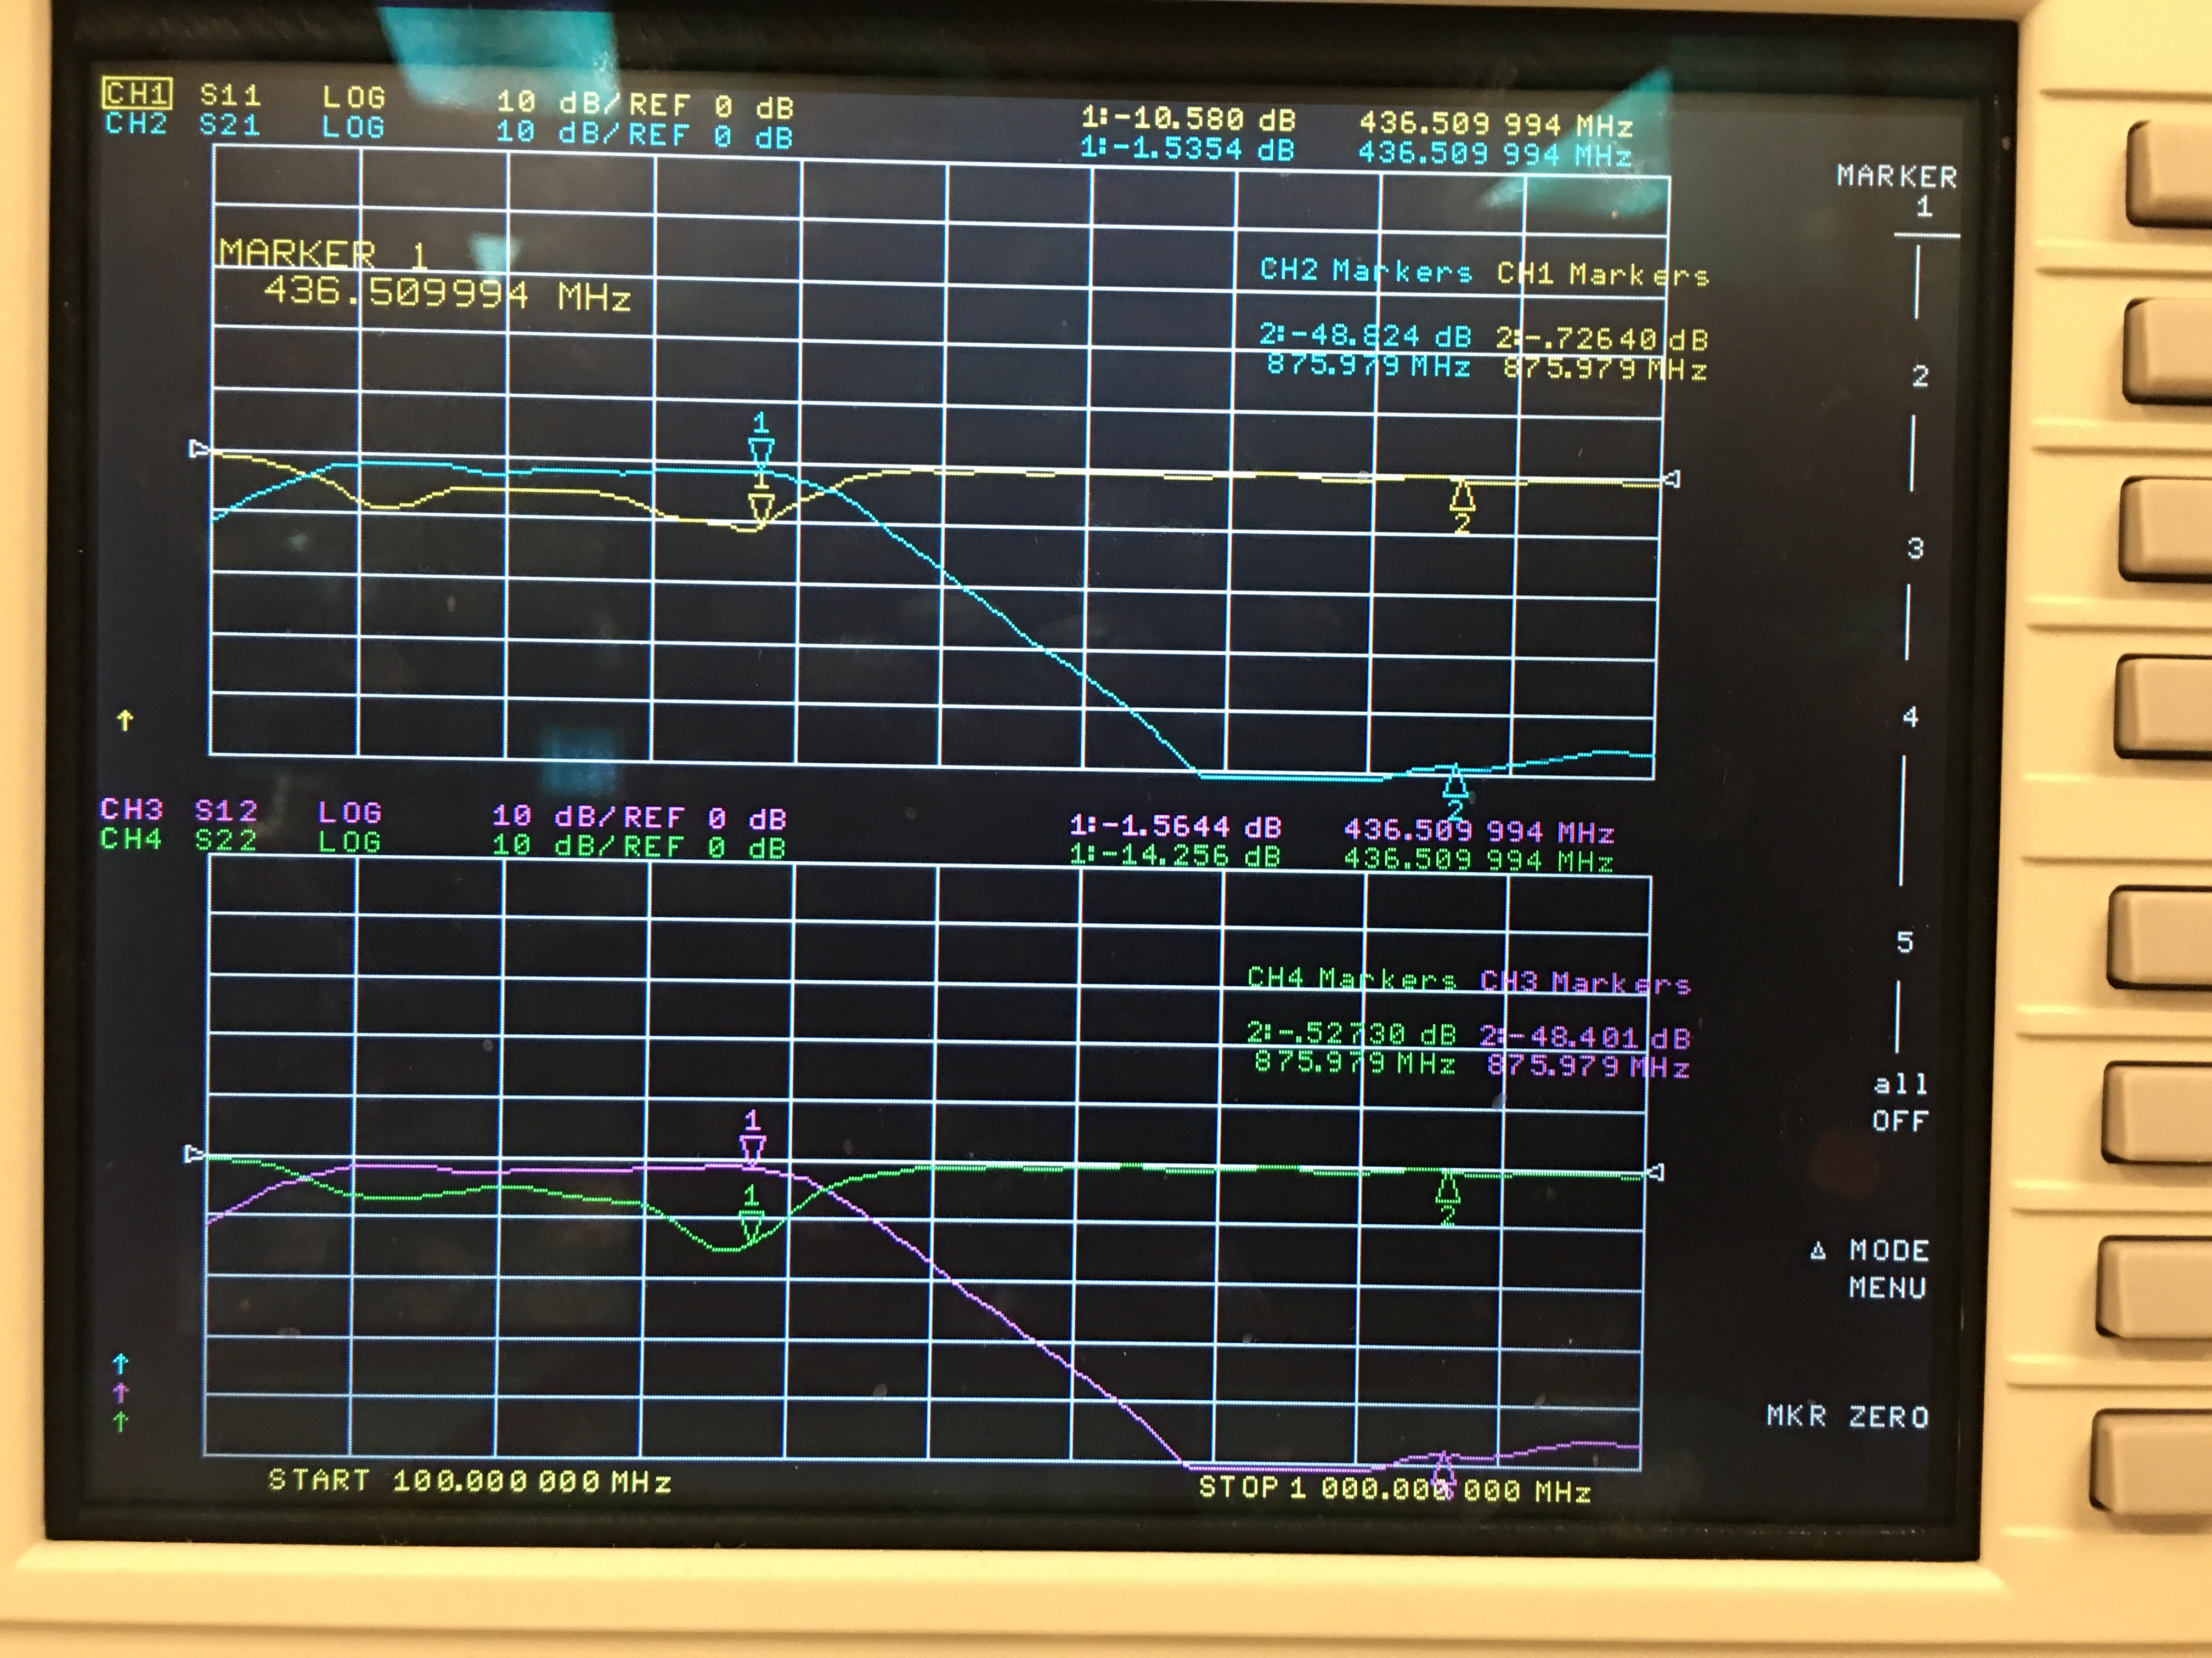

Figure 5. 3rd Rev pass band response with final modification

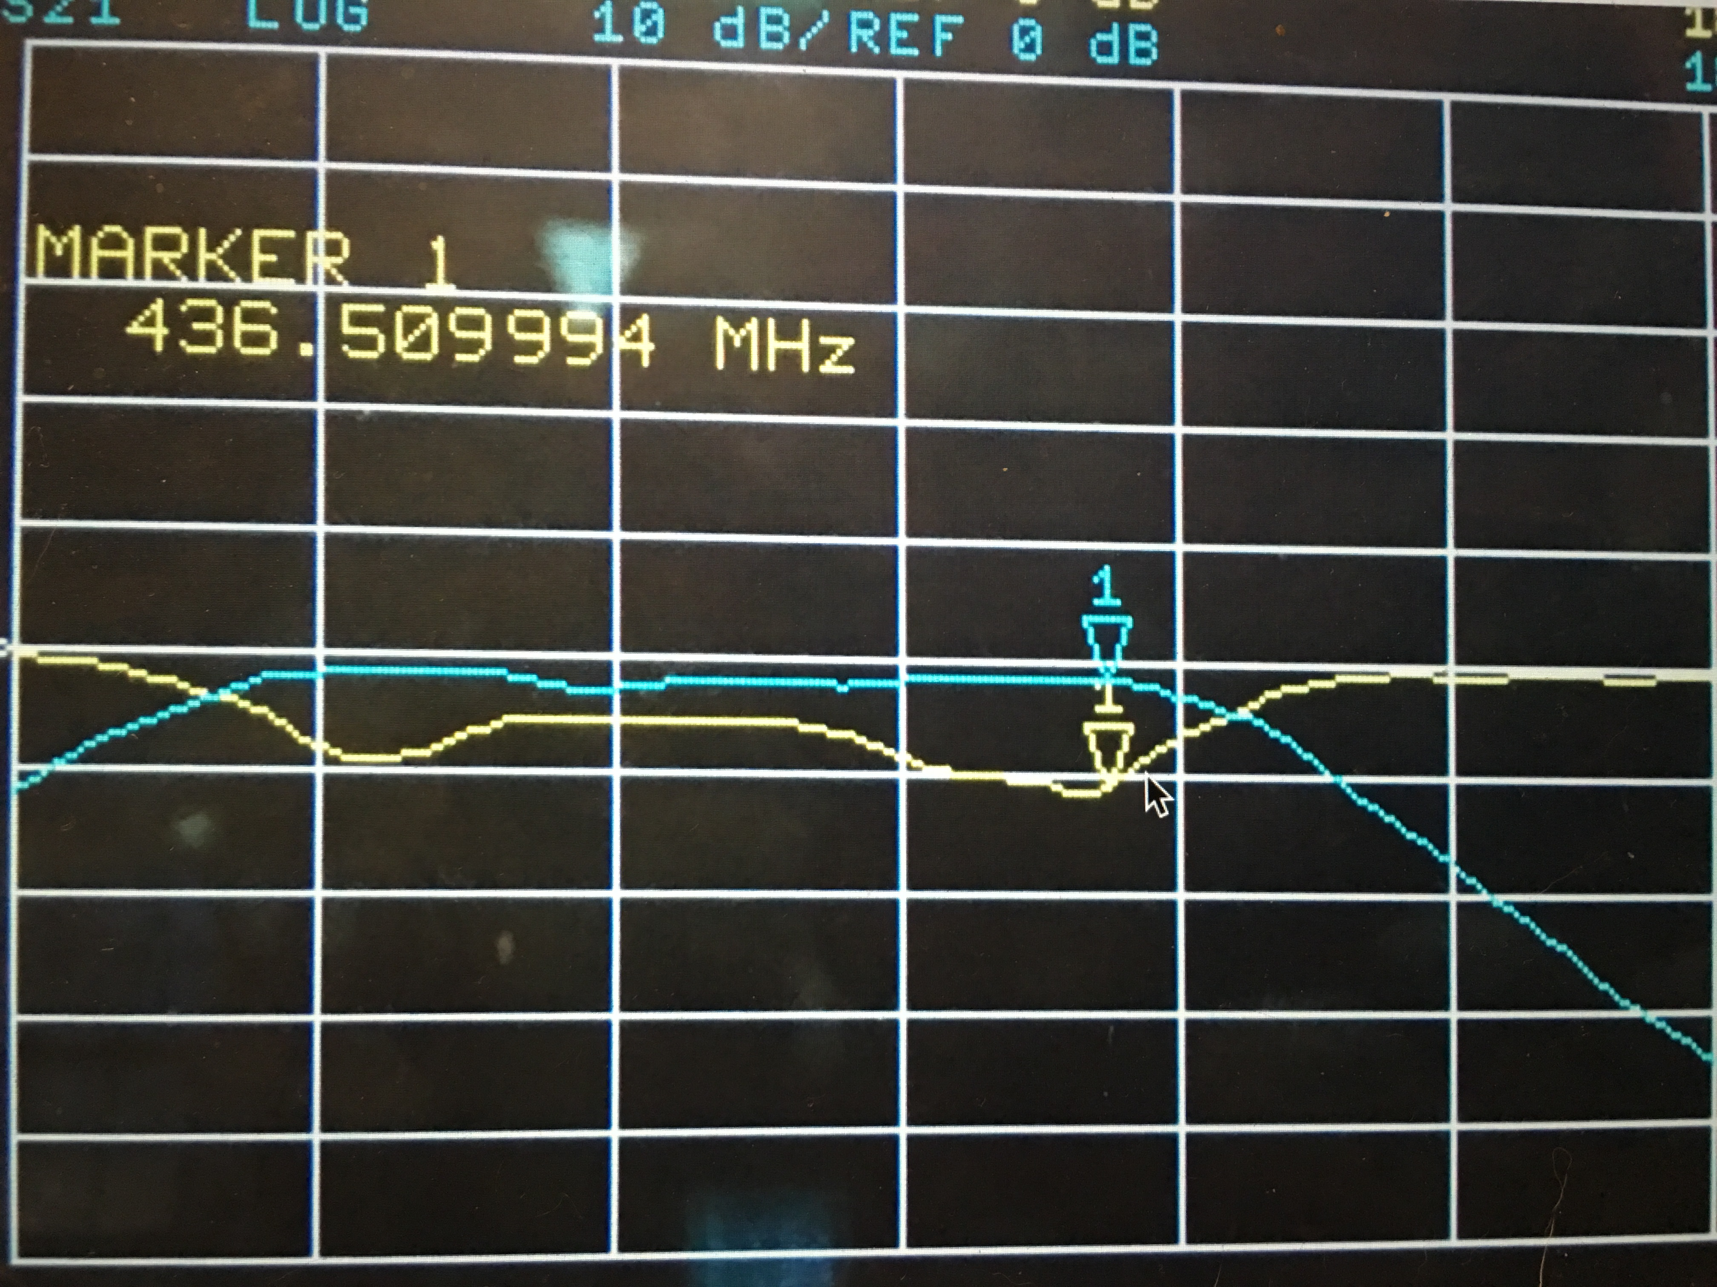

Figure 6. 3rd Rev pass band response (close-up) after final modification

The next image shows the attenuation of the 2nd harmonic of our 436.5 MHz signal. Here, it is shown that the 2nd harmonic is now attenuated by 48.8dB (it was -37dB before). This is great news since it shows that the filter is capable of proper 2nd harmonic attenuation.

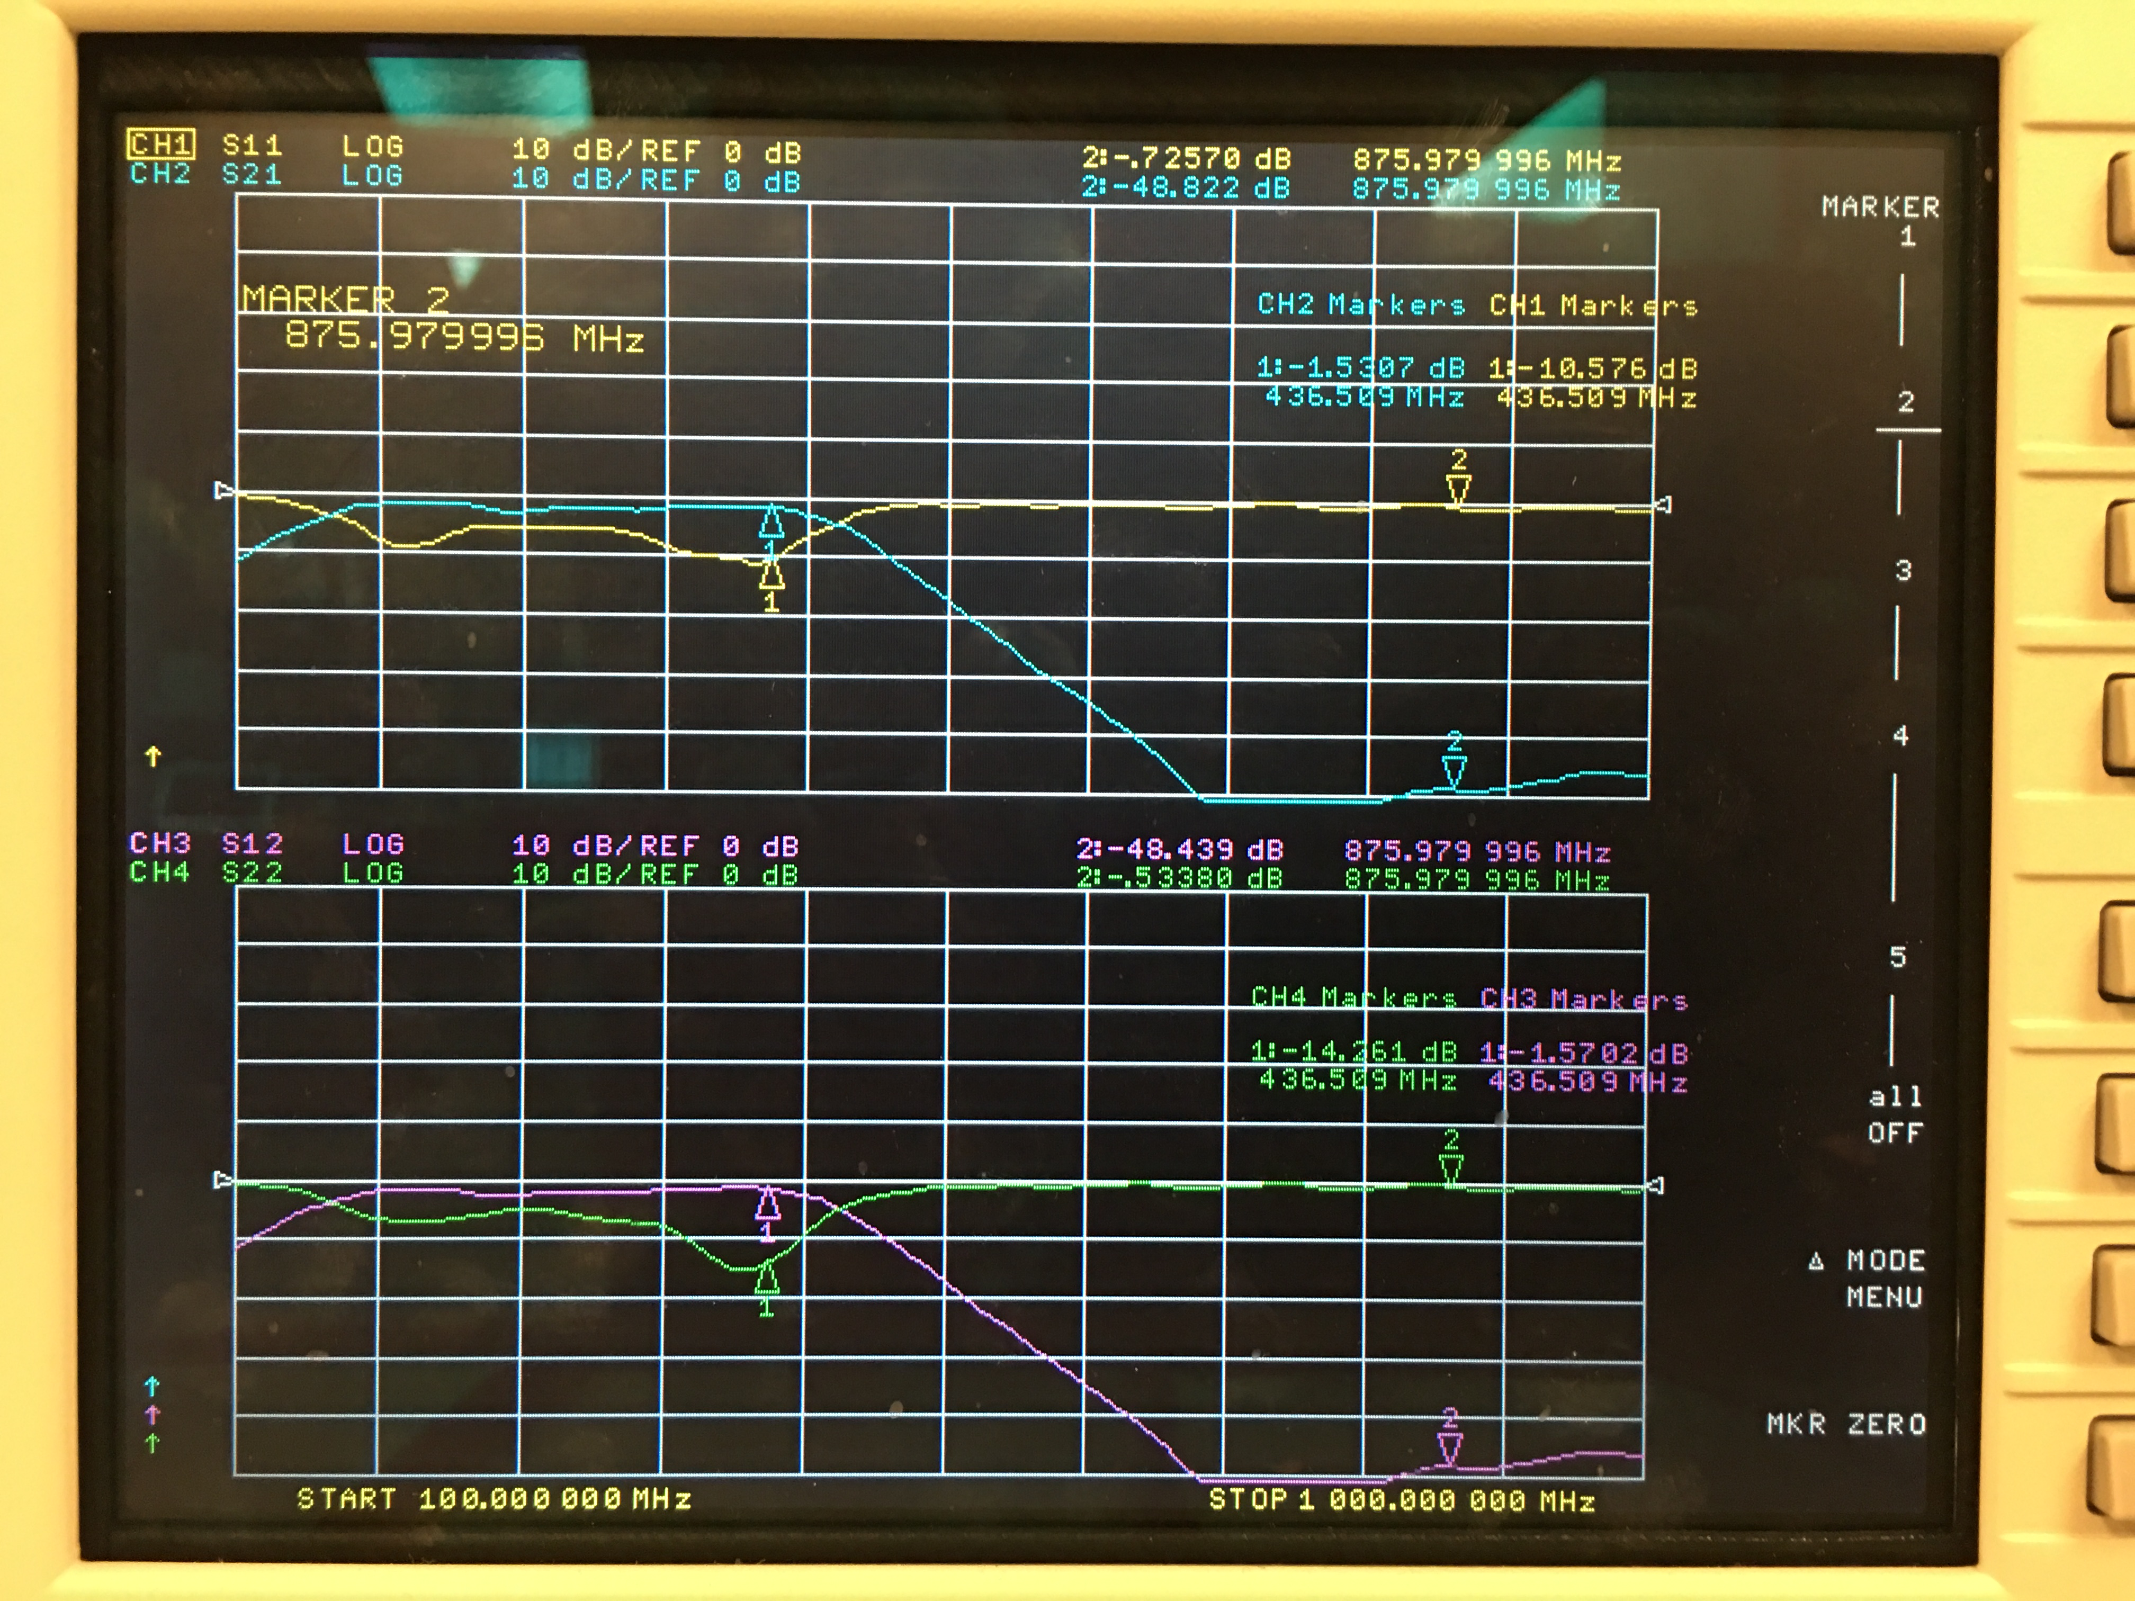

Figure 7. 3rd Rev 2nd harmonic response (close-up) with final modification

For comparison, the LTSpice simulation of this filter is shown below. It is interesting that the overall response is very similar between both the simulated filter and the built filter. The main difference is where the pass band of the two fall. It seems that the built filter is shifted down by about 50 MHz from simulation. This is most likely due to the characteristic impedance of the transmission line being off from 50 Ohms.

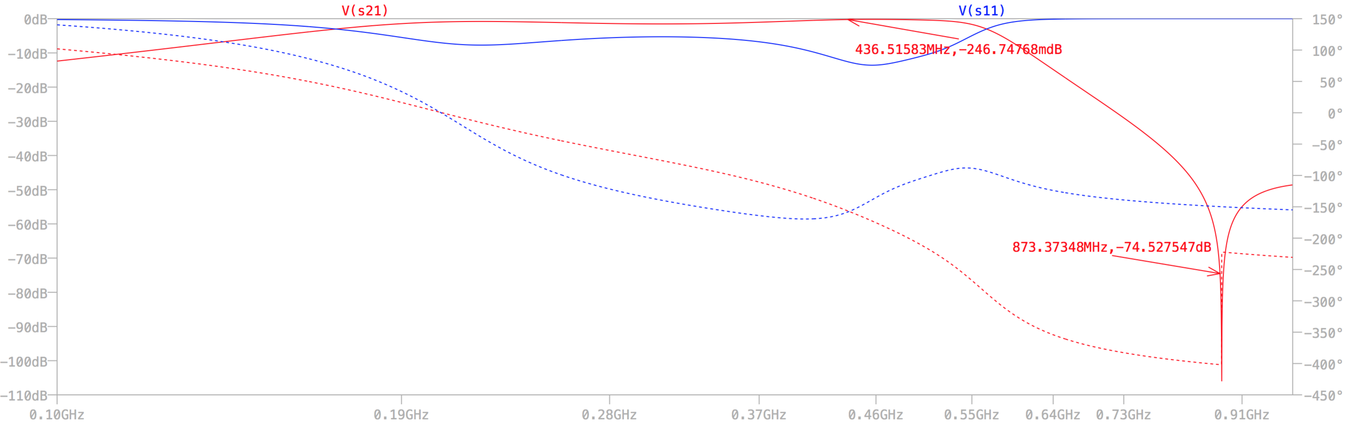

Figure 8. LTSpice plot of filter

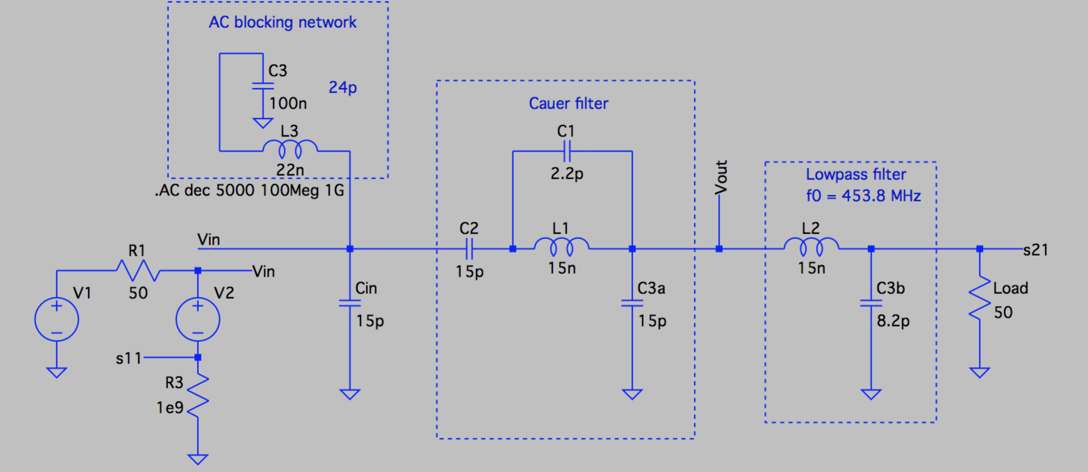

Figure 9. LTSpice schematic of filter with s11 and s21

Below is an image of the filter board after the vias were drilled. Note: for future designs, the vias will be incorporated into the design and fabricated by the router. Notice how most of the vias are placed next to grounded components. One via is floating in the ground plane. This process is loosely called “stapling”. I suggest using this technique to form a line of vias on the board where the copper tape is not feasible. In essence, we will create a box around the RF waveguides to connect the ground plane on the bottom layer to the ground plane on the top layer.

Image 10. 3rd Rev board with via drillings

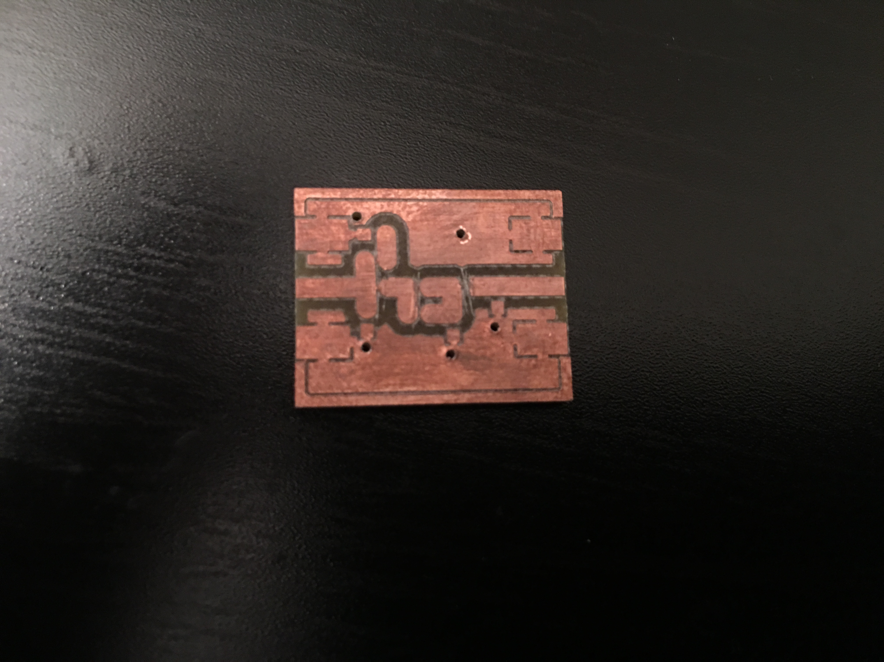

The image below shows the final design of this (3rd Rev) filter. The copper tape can be seen on the top and bottom of the board. Also, the solder joints are obvious where the vias were made and completed using wire as conductors between the top and bottom ground planes.

Image 11. 3rd Rev board complete

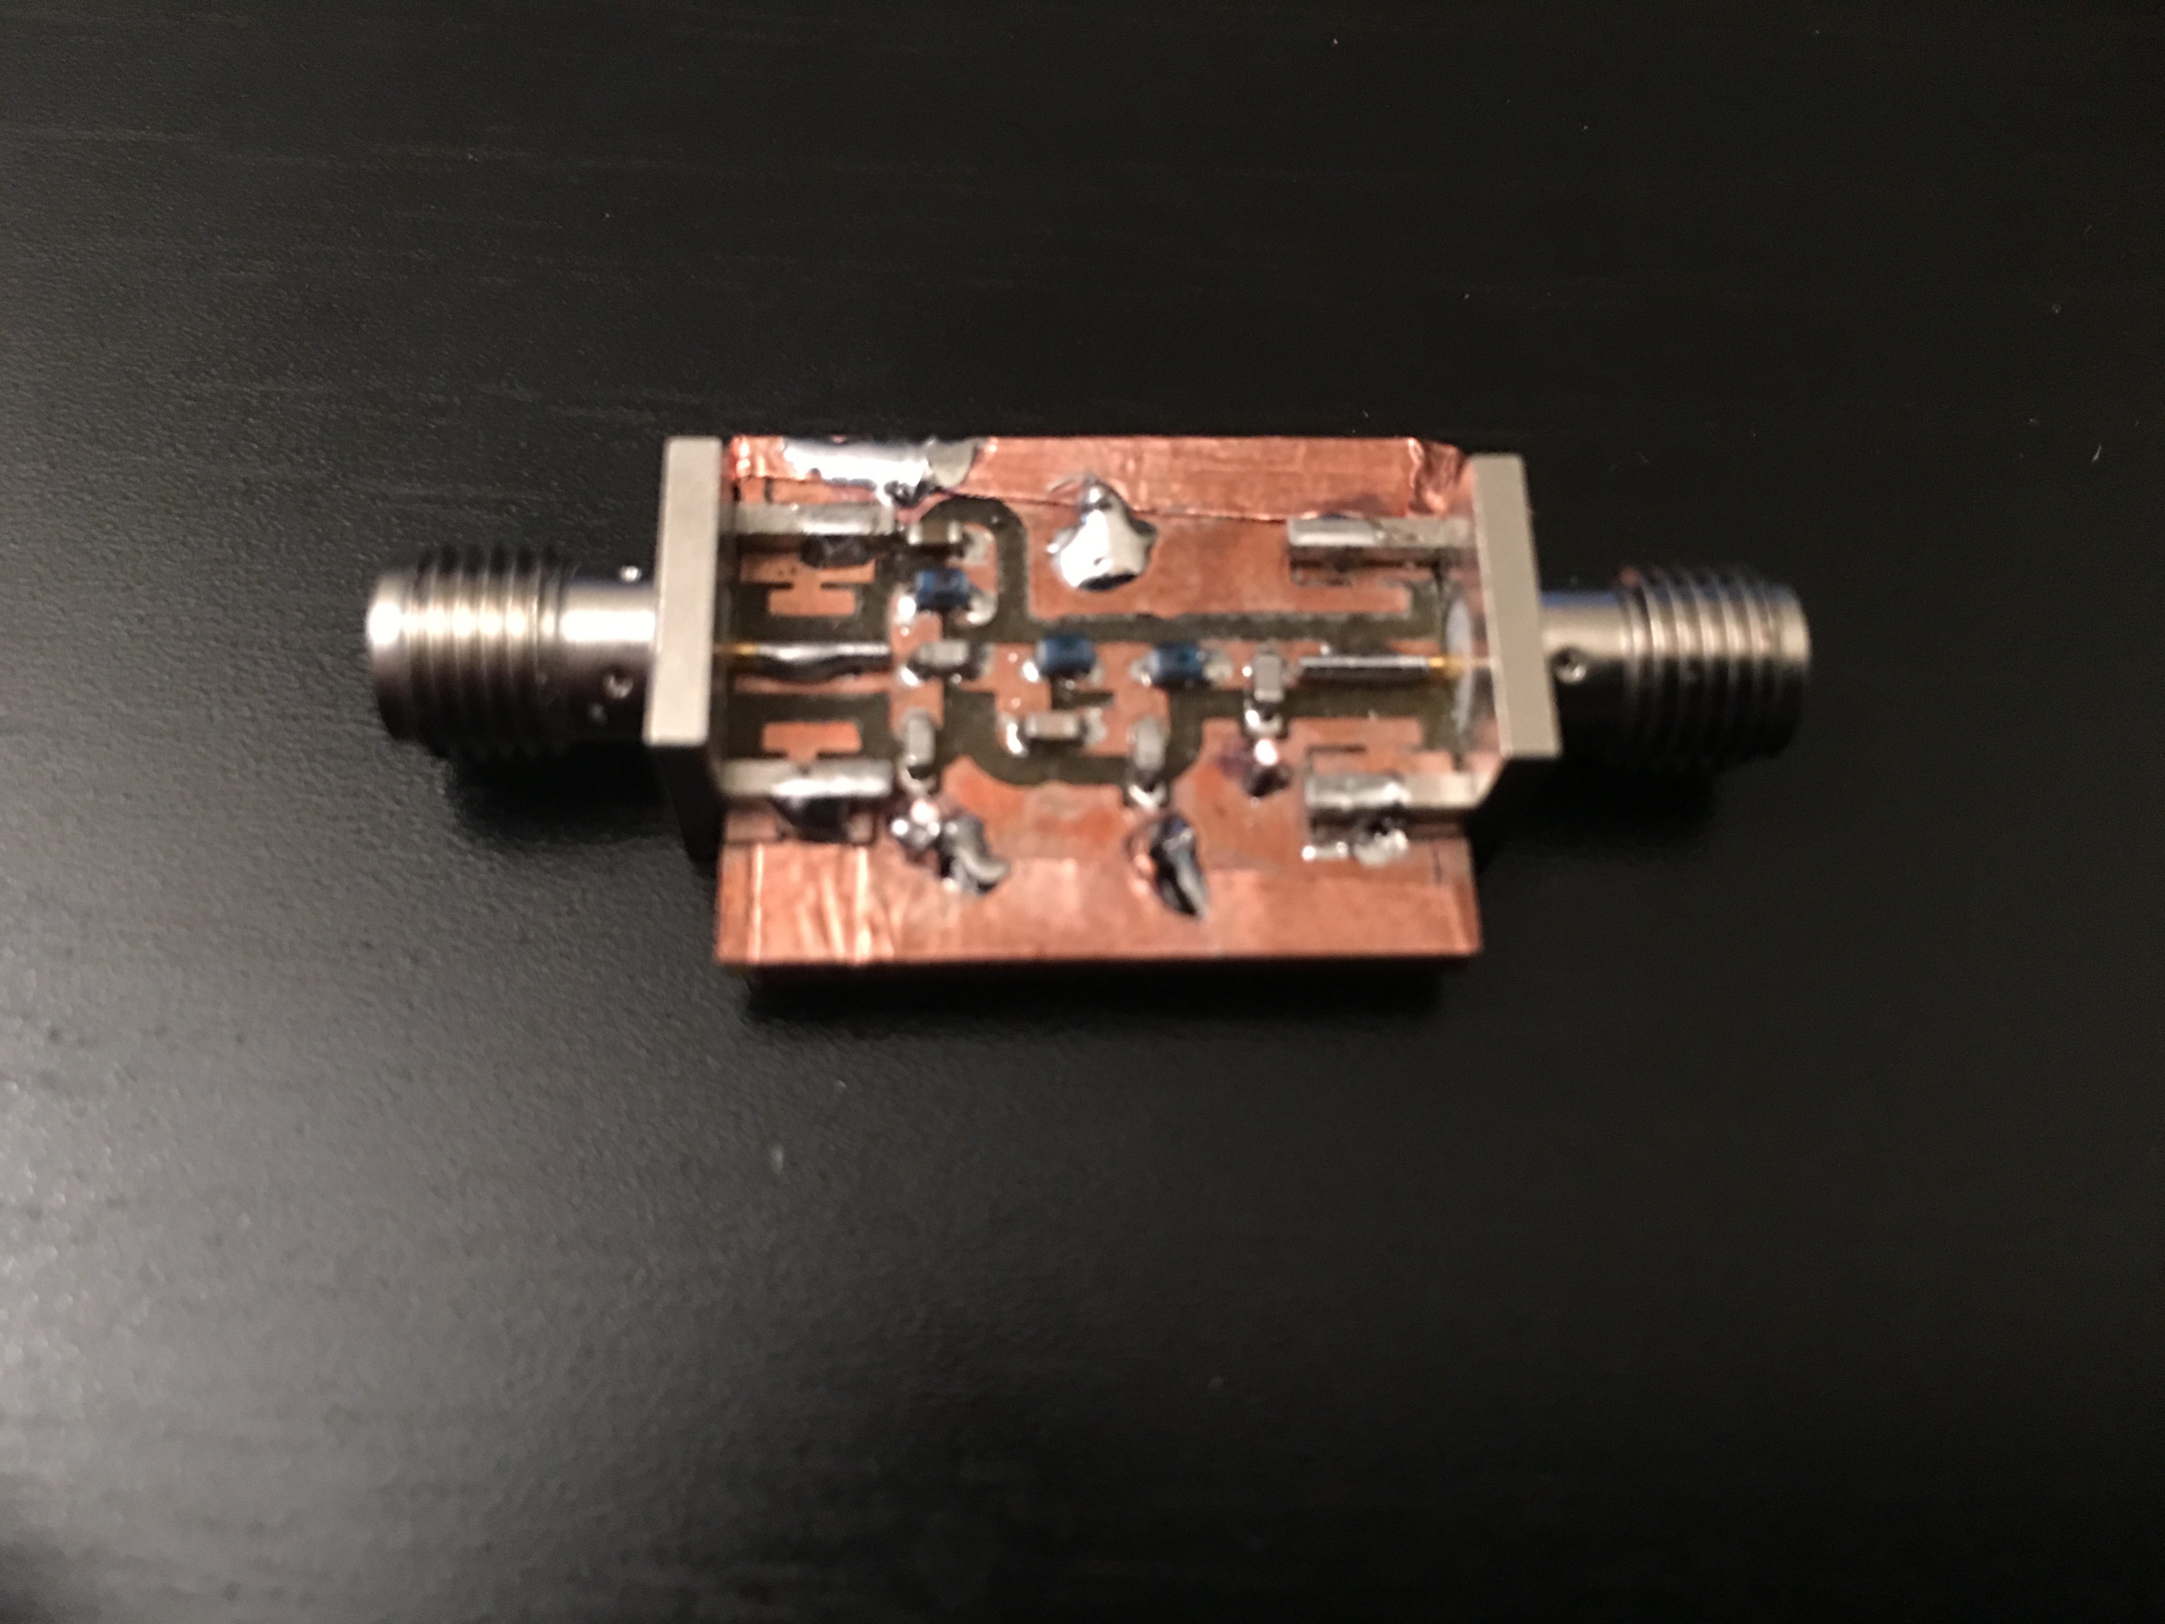

For comparison, the 1st, 2nd, and 3rd versions of the filters are shown below. Here, it can be seen that as the design improved so did the technique. The component placement is minimized so to reduce transmission line. Also, we added an AC blocking network to the final design so it actually has more components than the previous two.

Image 12. 1st, 2nd, and 3rd Revs of the filter layout

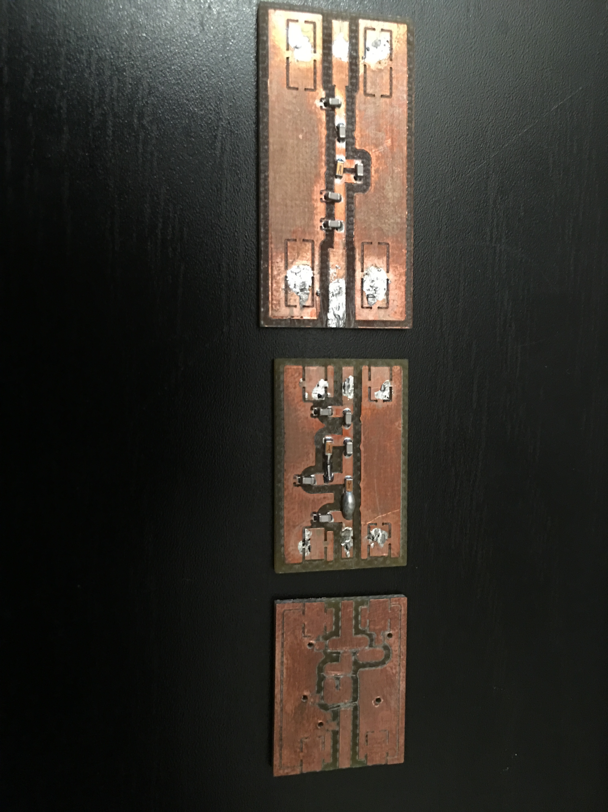

*Final Thoughts*

This filter is far from perfect, but should be fine to use for practicum

* S11 needs some work. Currently we are passing about 60% - 70% of the signal at the desired 436.5 MHz frequency
* We need to determine the bandwidth of the signal that we are going to use for the CubeSat so that we can adjust the pass band of the filter accordingly.

We could consider using tunable capacitors to dial in the response of the next generation of this filter. I think we can choose 2 or 3 caps that will be significant enough in the response to make them tunable. We can either tune them and leave them on the board or carefully desolder them and determine their actual capacitance by testing them at the signal frequency.